1) Import Word doc into InDesign:

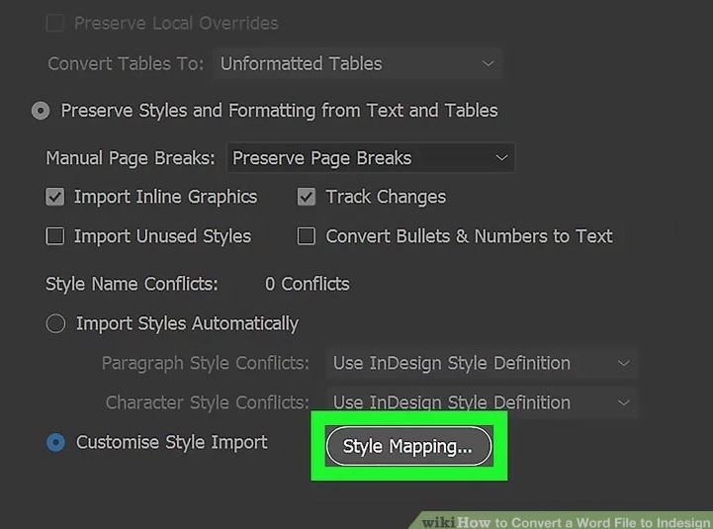

File->Place->Choose Word doc->Customize Style Import->Style Mapping

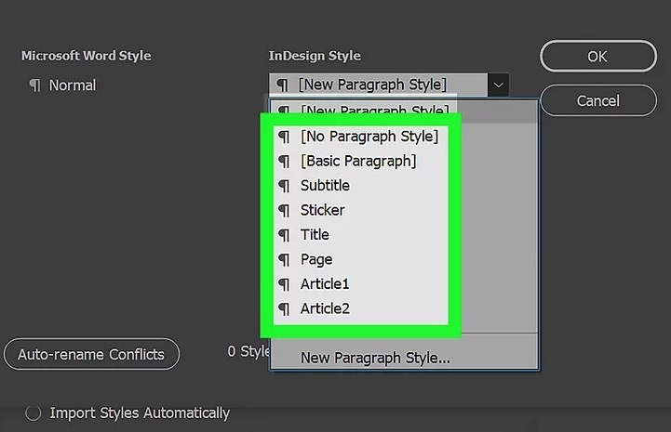

Map each Word style to a corresponding InDesign style

Draw a text frame to place your Word document

2) Export InDesign to HTML:

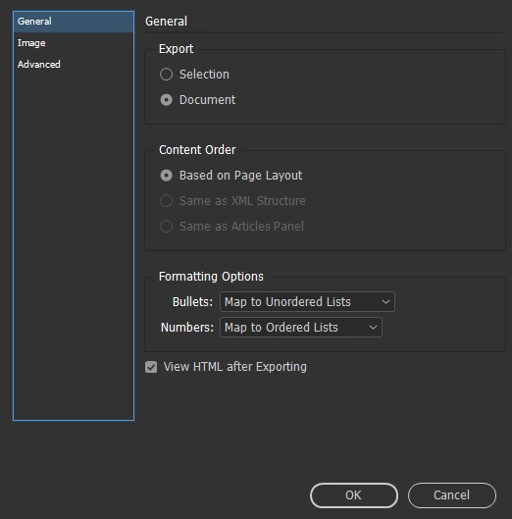

File > Export and select HTML from the Save As Type list

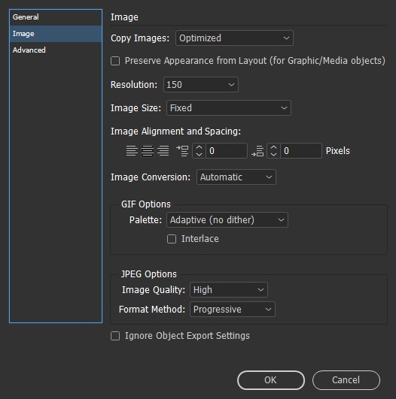

Specify the name and location of the HTML document, and then click Save

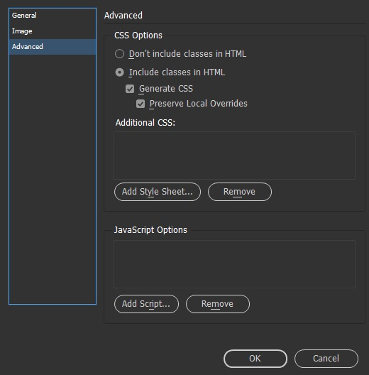

In the HTML Export Options dialog box, specify the desired options in the General, Image, and Advanced areas, and then click OK

InDesign to XML:

<https://creativepro.com/getting-started-with-xml-in-indesign/>

InDesign to XML Using XSLT File

<https://carijansen.com/indesign-xml-reference-guide/>

<https://carijansen.com/indesign-xml-reference-guide/>

<http://www.ozalto.com/en/all-you-need-to-know-about-using-xml-with-indesign/>

<https://www.w3schools.com/XML/tryxslt.asp?xmlfile=cdcatalog&xsltfile=cdcatalog>

Export InDesign to Word

Do they use Adobe Acrobat in between the process?

If so: <https://redokun.com/blog/indesign-to-word>

InDesign JavaScript Repos

javascript indesign site:github.com

<https://creativepro.com/product/javascript-for-indesign-2nd-edition/>

XSLT Designers

<https://www.altova.com/xslt-tools>

<https://www.oxygenxml.com/xml_editor/xslt.html>

XML Notepad (INSTALLED ALREADY)

Notes

**SED –** command line to do F&R and other text manipulation

**PERL –** can use Perl scripts for F&R and other text manipulation

**REGEX –** Regular Expressions – JavaScript basically

<https://coderpad.io/blog/development/the-complete-guide-to-regular-expressions-regex/>