**Angular 8 MEAN full-stack CRUD Web Application**

**This is a MEAN full-stack CRUD — Create, Read, Update and Delete web application where a user can save their Product Name, Product Description, and Product Price from the Angular form and submit the form to the node.js server.**

I utilized **Node.js** v10.16.0, **NodeServer, NodeJS Backend API**, **NPM** v6.9.0, **MongoDB**and **MongoDB Shell** v4.0.10, **TypeScript** and **Angular CLI** 8.0.4.

I do not have MongoDB on this server so screenshots and explanations are below:

1. Create Product with $1.95 price screen

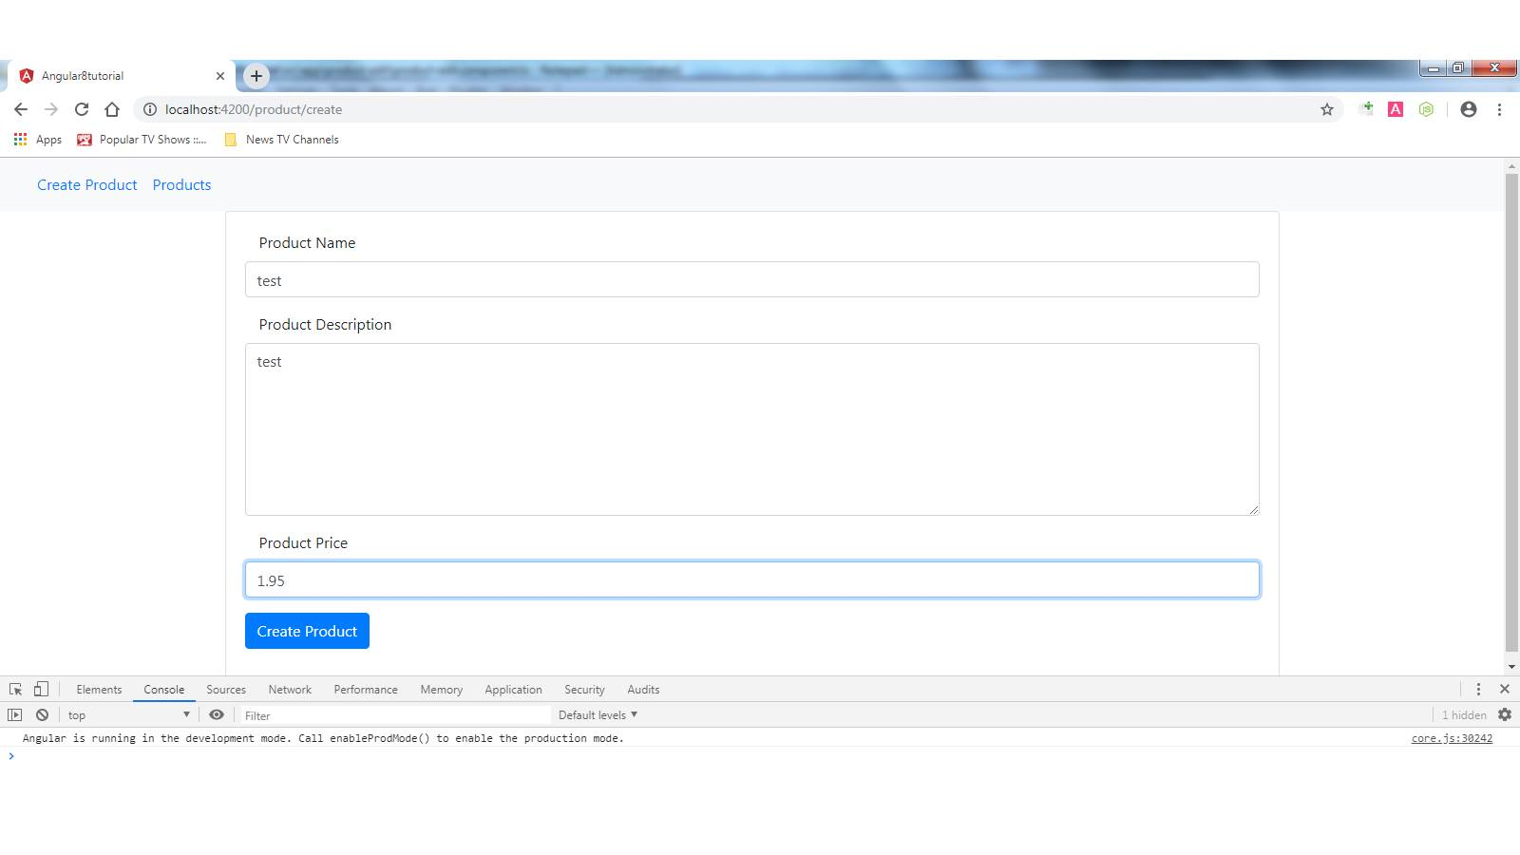  
2. Product Created screen

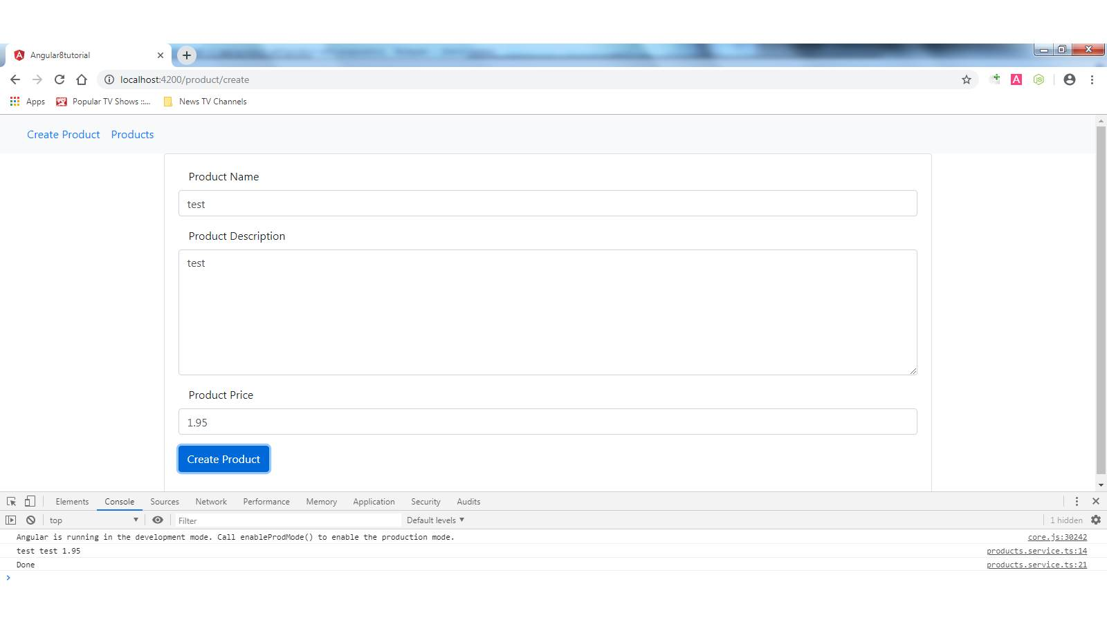  
3. View Products screen (price $1.95)

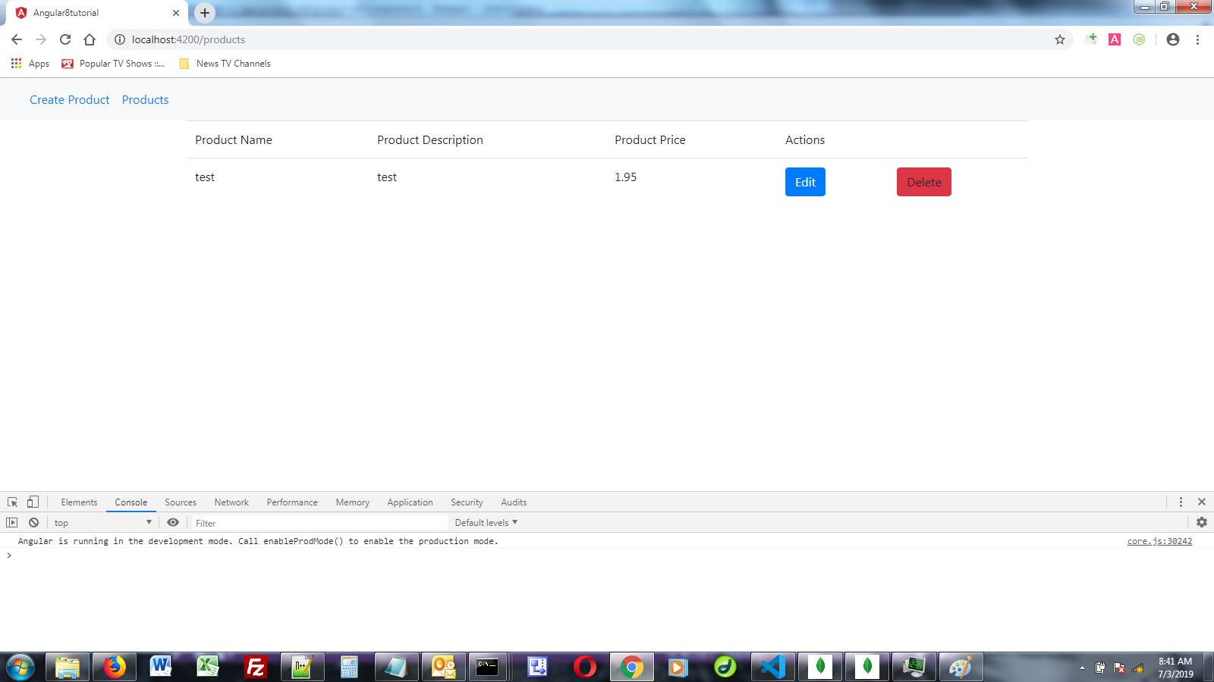  
  
  
4. Edit Product screen

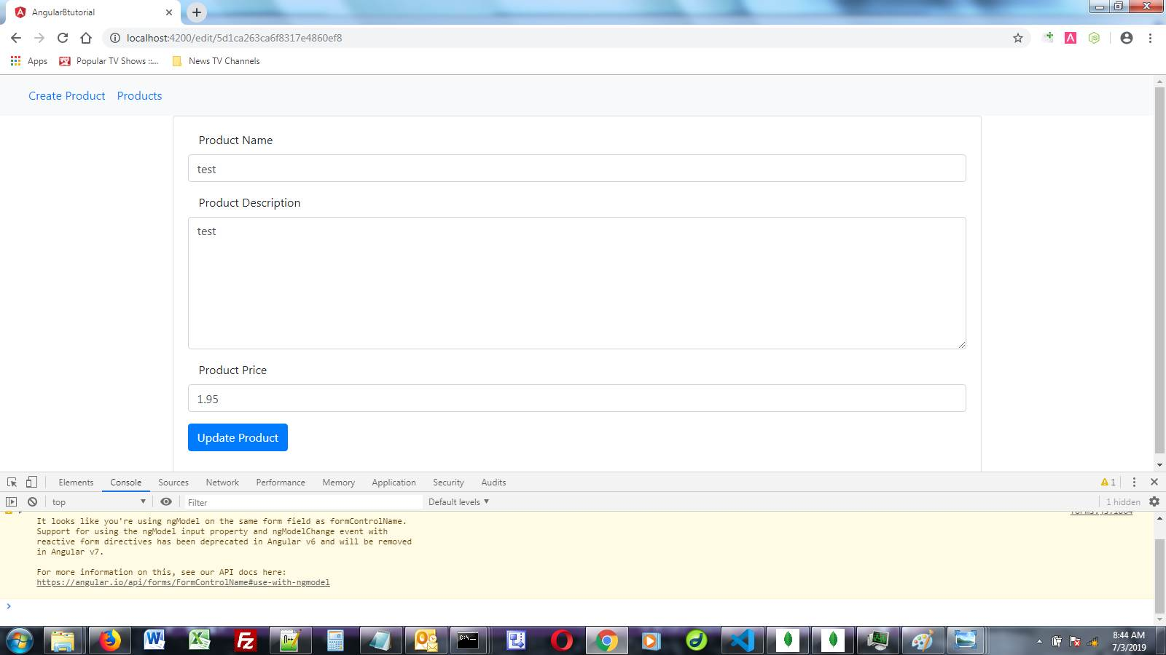  
  
  
5. Changed Product Price to $2.95 screen

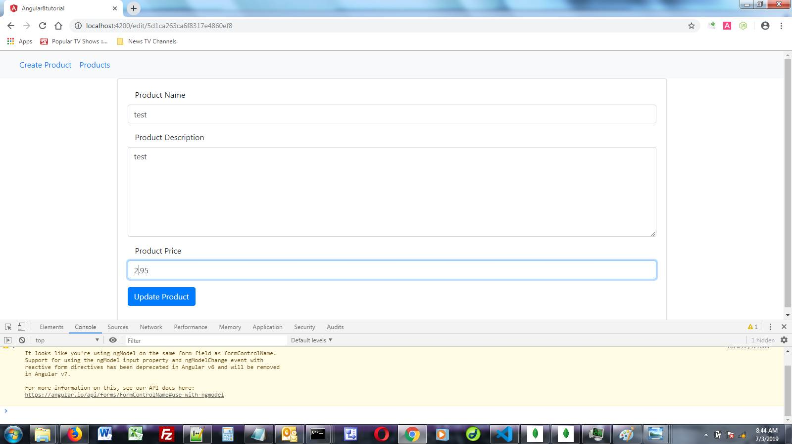  
  
  
6. Updated View Products screen (price now $2.95)

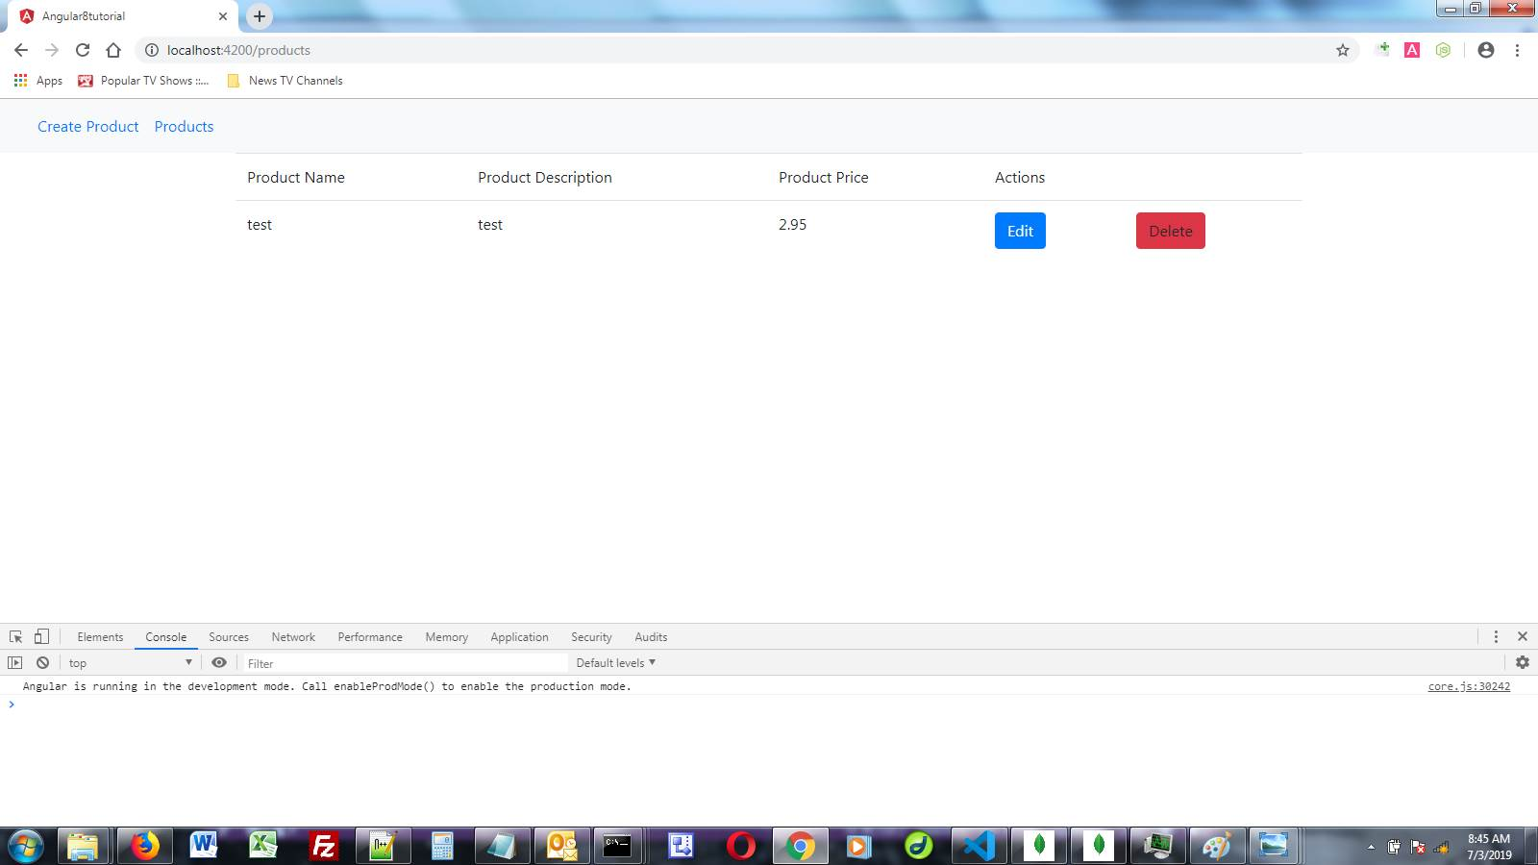  
  
  
7. Deleted Product screen

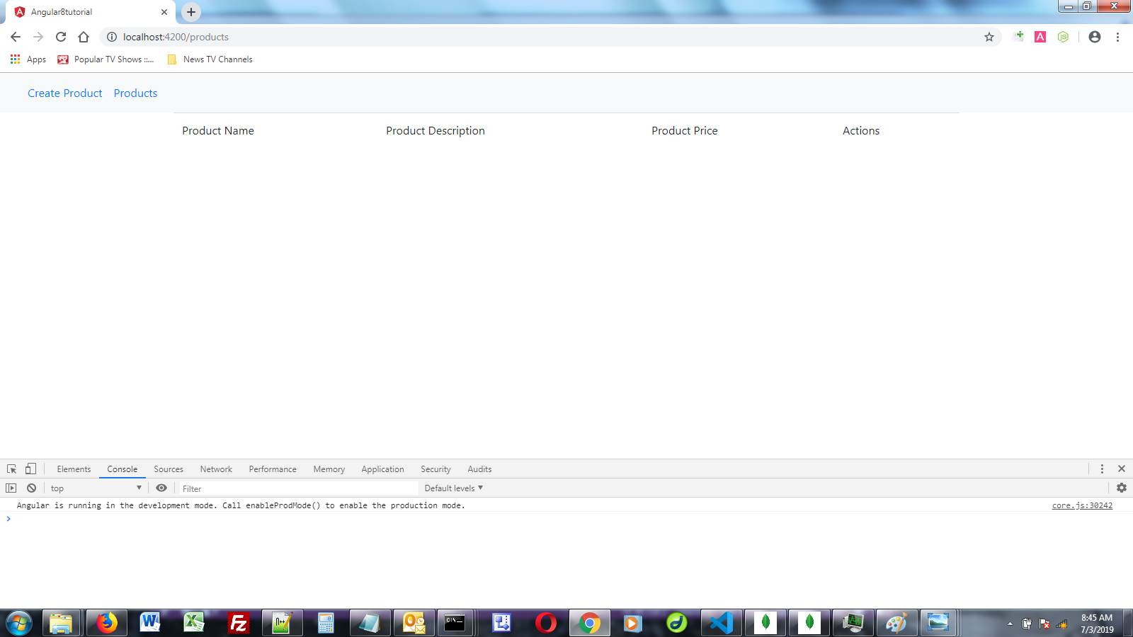  
  
  
8. Command window verifying the entry was stored in the Mongo Db.

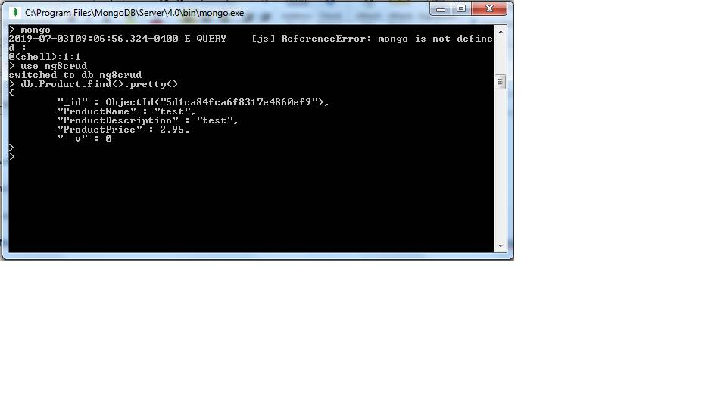

**JavaScript ES5 & ES6**

**Pure JavaScript ES6 Search Github Users App**

Takes user input and searches github.com then returns lists (fetches data) of matches based upon keystrokes.

Uses two different URLs from Github, one for users and one for Repos. Returns profile, list of public repos and a href links to each of them, number of public gists, number of followers and number of users account is following. Also has error management and displays an alert (if/else statement) in case a user is not found.

Uses JavaScript ES6, HTML5, and CSS3 locally. Also uses Bootstrap v4.0.0-beta.2, Bootswatch, jQuery v3.2.1, and popper.min.js delivered through a CDN.

Uses async await and the fetch API. Creates a UI class that inserts info.into the DOM. Connects via a key up event, so as you spell it returns matches. Uses Github client ID and client Secret within the API.

Displays the latest repositories (in this app it displays up to 66 repositories).

**Pure JavaScript ES5 and ES6 Book List Generator**

Takes user input and creates a list of books.

User adds title, author, and ISBN#, then clicks on SUBMIT. List is dynamically created below and user has the ability to delete individual entries.

Uses JavaScript ES5 (V1) and ES6 (V2), Skeleton CSS, and HTML5. Uses if else statements, local variables, classes, events, event listeners, validation, functions, methods, forEach, loops, constructors, UI.prototype, and e.preventDefault, static, JSON.parse and JSON.stringify.

The book list is saved/persisted into local storage, so if a user closes the browser and returns to the page, the values are saved in the users browser.

If a user removes a book, it is removed from both the app and from local storage.

If a user clears the browser cache the local storage is also cleared. If a user opens an incognito/private window, local storage is cleared.

**Pure JavaScript ES6 Number Guesser Game**

Takes user input and tests against a random number prechosen by the JavaScript web app.

Uses JavaScript ES6, Skeleton CSS, and HTML5.Uses events, event listeners, validation, functions, getRandomNum, and Math.random.

Player must guess a number between a min (1) and max (10). Player gets a certain amount of guesses (3). App notifies player of the number of guesses remaining. App notifies the player of the correct answer whether or not they win or lose. Player can choose to play again.

**Pure JavaScript ES6 Task List**

This web app uses JavaScript ES6 along with materialize css, font awesome, html5 and jQuery to produce a task list using the DOM.

The task list allows users to add tasks, filter tasks, and remove individual tasks or clear all tasks.

The tasks are saved/persisted into local storage, so if a user closes the browser and returns to the page, the values are saved in the users browser.

If a user removes a task, it is removed from both the app and from local storage.

If a user clears the browser cache the local storage is also cleared. If a user opens an incognito/private window, local storage is cleared.

It uses events, event listeners, JSON.parse to get tasks from local storage, for each loops, functions, and JSON.stringify to store to local storage in the browser.

**Pure JavaScript ES6 Loan Calculator**

Takes loan amount, interest rate and number of years to calculate the monthly payment, the total payment and total interest paid.

Uses JavaScript ES6, jQuery, Popper.js, Bootstrap JS, Bootstrap 4 CSS, and HTML5.

Utilizes events, event listeners, error handling, setTimeout, if else statements, Math.pow, and displays a loader animation (loader.gif) and an error popup if fields are empty or contain invalid input.

**Vue.js**

**Vue.js Web App**

Vue.js is a JavaScript front-end framework that was built to organize and simplify web development.  
  
The project focuses on making ideas in web UI development (components, declarative UI, hot-reloading, time-travel debugging, etc.) more approachable. It attempts to be less opinionated and thus easier for developers to pick up.  
  
It features an incrementally adoptable architecture. The core library focuses on declarative rendering and component composition and can be embedded into existing pages. Advanced features required for complex applications such as routing, state management and build tooling are offered via officially maintained supporting libraries and packages.

**Angular 1.x Samples**

**Angular 1.6 Tour of Heros**

This an Angular 1.6 app that demonstrates how, for example, a staffing agency could potentially manage its stable of heroes.  
  
This basic app has many of the features found in a data-driven application. It acquires and displays a list of heroes, edits a selected hero's detail, and navigates among different views of heroic data.  
  
The app demonstrated Angulars ability to:

* Use built-in Angular directives to show and hide elements and display lists of hero data
* Create Angular components to display hero details and show an array of heroes
* Use one-way data binding for read-only data
* Add editable fields to update a model with two-way data binding
* Bind component methods to user events, like keystrokes and clicks
* Enable users to select a hero from a master list and edit that hero in the details view
* Format data with pipes
* Create a shared service to assemble the heroes
* Use routing to navigate among different views and their components

This app was created by Matthew Lind in Angular 1.6 03/2018.

**Angular 1.6 Web Site**

This is a mobile-responsive web site built using Node, Angular 1.2, Angular 1.6, HTML5, CSS3, Bootstrap, jQuery, and various JavaScript libraries.

**Angular 1.6 Shopping List**

Shopping List built in Angular 1.6 and has error management. If you put a duplicate item in the list an error message is displayed.

**Angular 1.6 To-Do List**

To-Do List built in Angular 1.6 and has required field. If you fail to input text in the form field a warning dialog is displayed.

**Angular 1.3 REST API Call**

Demo of Angular 1.3 Rest API Calls in AngularJS using $http Service and http://jsonplaceholder.typicode.com data

**Angular 1.2 Contact Form**

Form uses app.js and controller.js for form controls, and in the code it uses ng-app, ng-controller, ng-class, ng-disabled, and ng-model. Form uses phpmailer to post form results via email. It has error management, all fields are required fields, and has data validation on the email field to confirm there is an actual email address in the field before it will post results.

**Laravel**

**Laravel server installation demo**

This web site required Python, Dropwizard, Maven, Java SE Dev Kit, JDK 11.0.2, and JavaScript Runtime to install.

**React.js**

**React.js Calculator**

This is a mobile-responsive calculator based on the iPhone calculator, built using React.js.

**Tic Tact Toe Game**

Interactive tic-tac-toe game built with React and normalize.css.

Uses javascript ES6 arrow functions, classes, let, and const statements; uses mousedown, keydown, and click event listeners.

Used [Babel](https://babeljs.io/repl) to compile ES6 code to react.

**PERL**

**PERL Search Script**

This is a PERL script that indexes and searches the web site and was built using PERL, Perlfect, Node, HTML5, CSS3, Javascript and Angular 1.6. The results return a string that does not index the site properly as the search engine script was not built for use with Angular 1.6, but it shows that I am able to implement PERL scripts and CGI Scripts on a web site. The script is better suited for non-Angular web sites.

**PHP**

**PHP Scripts**

Domain Name WhoIs Search written in PHP using classes, .lst files, and custom functions.  
  
PHP display images in a folder script A PHP script that displays automatically images all that are in a particualr folder on a web server.

**JQuery**

**jQuery Samples**

These are animated effects Matt Lind added to web sites that add flair, notoriety and credibility to a web site.  
  
**Animated Image Gallery**

**Peel Backs**  
  
These are jQuery peel back web applications and are on the top right or left of a web page, or across the bottom or top of a web page, or on the left side or right side of a web page and when you hover over them a larger graphic is displayed. Within the larger graphic can be links to other parts of a web site or web page.  
  
**Popups**  
  
These popup over the whole page on a web site and can make a user have to perform an action (like enter an email address or phone number) to continue...  
  
**Slideshow Web Applications**  
  
These can be slide shows of a community, a home, or other photos.

(HTML5 and CSS3 Mobile Responsive Slideshow)

(Fixed Width, Cross-browser Slideshow)  
  
**Scroller Web Applications**  
  
These are automated slideshows of usually 3-5 graphics that slide thru on a web page and have thumbnails at the bottom to click on.  
  
**Balloon Popover Web Applications**  
  
These popup small balloons with more details when you hover over a word in some text. This is desgned as a desktop application with use of a mouse. Not designed for mobile devices.

**Image Popover Web Applications**These popup larger images when you hover over a smaller image. Not designed for mobile devices.

**Slider Web Applications**  
  
These slide from one photo to another with numerous animated effects available for the transistions between photos.

**Web Application Video Production Samples**

**Video Productions made by Matthew Lind**

Software Video Tutorials (Made using Camtasia)

Live Software Video Tutorial (done via Skype)

**DHTML**

**DHTML Samples**

DHTML Fireworks (desktop only)

DHTML Curtain Open

DHTML Snow (desktop only)

**Java Applets**

**Java Applets (IE Only)**

Applet Samples (IE only)  
These Applets **worked** for me in IE11. They didnot work for me in Firefox or Opera. I did not try them in Chrome.  
(you have to have [Java](https://java.com/en/download/) installed and enabled. Then you have to [configure the Exception Site](https://java.com/en/download/faq/exception_sitelist.xml) and add http://overbrd.com to the List for the Applets to run)

**Web Banner Design**

**Web Banner Design**

Samples of banners Matt Lind has made available upon request.

**Postcard and Brochure Design**

**Postcard and Brochure Designs by Matt Lind**

These are samples of postcards and brochures I have made over the past 20 years. They are mostly designs I made for real estate brokers and real estate agents between 2002 and 2014.  
  
I also have printed out samples available for viewing upon an onsite interview.   
  
I have created hundreds of brochures, thousands of postcards, and many other types print and web materials from scratch.   
  
If you would like specific examples of designs other than brochures and postcards not listed here, please [Contact Me](mailto:mattlindco@mail.com).

**All Other Samples**

**Flash**

Sample Flash galleries built by Matt Lind available upon request.

**Web Application Form Validation (AJAX and JavaScript)**

Form Validation examples available upon request.

**Web Application Video Embedding**

Sample video embedding available upon request.

**Web Button Design**

Available upon request.

**Web Icon Design**

Available upon request.

**Email Stationery Design**

Available upon request.

**Web Themes for Perl User Interface**

Available upon request.

**Web Page Graphic Design**

Available upon request.

**Logo Design**

Available upon request.

**Design Portfolio**

WordPress Themes & Templates

Graphic Design

Joomla Web Site

jQuery Single Page Application (SPA)

1-Page Web Sites & Landing Pages

JavaScript on GitHub

**About**

Over 20 years' experience designing web sites using technologies including AJAX, Angular, API's, Applets, ASP, Bootsrap 4, CSS, CSS3, DHTML, Fireworks, Flash, HTML, HTML5, Illustrator, JavaScript, jQuery, LESS, MySql, MySqli, Node, PERL, Photoshop, React, PHP 7, SASS, SCSS, VBScript, and XML.

Custom web and graphic design.Custom CMS template and theme creation and programming using WordPress, Joomla, Drupal and others.ECommerce integration using Magento, PayPal, OS Commerce, and ZenCart.

Advanced mobile responsive web design & programming. Modules, Plugins, Custom Enhancements, Custom Programming, and much more...

**WordPress Themes and Templates**

[Outdoor Sports Group](http://www.outdoorsg.com/)  
(mobile responsive; contributed as Responsive Web Developer, QA Software Tester)

[The Sportsman Channel](http://www.thesportsmanchannel.com/)  
(mobile responsive; contributed as Responsive Web Developer, QA Software Tester)

[Guns & Ammo Magazine](http://www.gunsandammo.com/)  
(mobile responsive; contributed as Responsive Web Developer, QA Software Tester)

[Handguns Magazine](http://www.handgunsmag.com/)  
(mobile responsive; contributed as Responsive Web Developer, QA Software Tester)

[Rifle Shooter Magazine](http://www.rifleshootermag.com/)  
(mobile responsive; contributed as Responsive Web Developer, QA Software Tester)

[Shooting Times Magazine](http://www.shootingtimes.com/)  
(mobile responsive; contributed as Responsive Web Developer, QA Software Tester)

[Firearms News Magazine](http://www.firearmsnews.com/)  
(mobile responsive; contributed as Responsive Web Developer, QA Software Tester)

[Fly Fisherman Magazine](http://www.flyfisherman.com/)  
(mobile responsive; contributed as Responsive Web Developer, QA Software Tester)

[InFisherman Magazine](http://www.in-fisherman.com/)  
(mobile responsive; contributed as Responsive Web Developer, QA Software Tester)

[Game and Fish Magazine](http://www.gameandfishmag.com/)  
(mobile responsive; contributed as Responsive Web Developer, QA Software Tester)

[BowHunting Magazine](http://www.bowhuntingmag.com/)  
(mobile responsive; contributed as Responsive Web Developer, QA Software Tester)

[Bow Hunter Magazine](http://www.bowhunter.com/)  
(mobile responsive; contributed as Responsive Web Developer, QA Software Tester)

[Gun Dog Magazine](http://www.gundogmag.com/)  
(mobile responsive; contributed as Responsive Web Developer, QA Software Tester)

[North American Whitetail Magazine](http://www.northamericanwhitetail.com/)  
(mobile responsive; contributed as Responsive Web Developer, QA Software Tester)

[Wild Fowl Magazine](http://www.wildfowlmag.com/)  
(mobile responsive; contributed as Responsive Web Developer, QA Software Tester)

[Petersen's Hunting Magazine](http://www.petersenshunting.com/)  
(mobile responsive; contributed as Responsive Web Developer, QA Software Tester)

[Florida Sportsman Magazine](http://www.floridasportsman.com/)  
(mobile responsive; contributed as Responsive Web Developer, QA Software Tester)

[Bass Fan Magazine](http://www.bassfan.com/)  
(mobile responsive; contributed as Responsive Web Developer, QA Software Tester)

[Artists Network](http://www.artistsnetwork.com/)  
(mobile responsive; contributed as Responsive Web Developer)

[Writers Digest](http://www.writersdigest.com/)  
(mobile responsive; contributed as Responsive Web Developer)

[How Design](http://www.howdesign.com/)  
(mobile responsive; contributed as Responsive Web Developer)

[Deer & Deer Hunting](http://www.deeranddeerhunting.com/)  
(mobile responsive; contributed as Responsive Web Developer)

Asentra Health (site offline now)  
(mobile responsive; contributed as Responsive Web Developer) [WEB SITE NO LONGER ONLINE]

[Romano Income Strategies](http://www.romanoincomestrategies.com/)  
(mobile responsive)

[Shop Deer Hunting](http://www.shopdeerhunting.com/)  
(e-commerce)

[Artists Network](http://artistsnetwork.tv/)  
(contributed as Responsive Web Developer)

[Adams Media](http://www.adamsmedia.com/)  
(contributed as Responsive Web Developer)

[Craft Daily](http://craftdaily.com/)  
(contributed as Responsive Web Developer)

The Data Stock (site offline now)  
(contributed as Graphic Designer and Web Developer)

The Media Crew (site offline now)  
(contributed as Graphic Designer and Web Developer)

* Clients: **The Media Crew (site offline now)** **|** [**F&W Media**](http://fwcommunity.com) **|** [**KSE Holdings**](http://outdoorsg.com)
* Dates: **2011 - 2019**
* Services: **Web Development, QA Software Testing, UI/UX Development, Wordpress Development**

**Graphic Design**

Matt Lind has designed hundreds of graphics from concept to completion using Adobe Creative Suite. With these graphics he has made single web pages, web sites, web templates, single page web applications and web themes including those for use in Wordpress, Joomla, Drupal, Coppermine, Magento, OS Commerce and many others.

Online protfolio of postcards and brochures.

* Clients: **Small Businesses & Small to Large Corporations**
* Dates: **1999 - 2019**
* Services: **Graphic Design, Theme Design, Template Design, Banner/Icon/Logo Design, Postcard/Brochure Design**

**Joomla Web Sites**

Built corporate web site from concept to completion.Contributed as site creator, Graphic Designer and Web Developer.Utilized web technologies including AJAX, CSS2, HTML4, JavaScript, Joomla, jQuery, MySql and PHP5.

* Client: [**Liner Source**](http://www.linersource.com/)
* Date: **2011**
* Service: **Web Development**

**jQuery Mobile Web Site - Single Page Application (SPA)**

Built Single Page Application (best viewed in a mobile device) using jQuery Mobile. Utilized CSS3, HTML4, jQuery, JavaScript.Contributed as site creator, Graphic Designer and Web Developer.

* Client: **Delray Computer**
* Date: **April 2010**
* Service: **Application Development**

**1 Page Web Sites/Landing Pages**

These are 1 page web sites that gather email addresses or other customer info. for promotions or other reasons. Designs Matt Lind has built are from concept to completion including all custom logos made with Adobe Illustrator. Web pages utilized AJAX, CSS3, HTML4, JavaScript, PHP.













* Client: [**The Media Crew**](http://mediacrew.com)
* Date: **2013**
* Service: **Graphic Design, Logo Design, UI/UX Design and Development, Web Development**

**JavaScript**



Samples of JavaScript web applications Matt Lind has used on web sites.

* Client(s): [**Various Scripts on GutHub**](https://github.com/Overbrd/JavaScript)
* Dates: **1999-2025**
* Service: **Web Development**